1. **Tools**

1.1、Encryption Tools: ARCEncryptTools.exe

1.2、IED: MDK

**2、Instructions:**

The encryption algorithm uses ARC encryption, with the key being

"QzBtDzKjYxGsWalkieTalkieBt8000OpenDate20241202". The encryption tool can be invoked through MDK -> Options for Target 'Target 1' -> User -> After Build/Rebuild, as shown in the following figure:

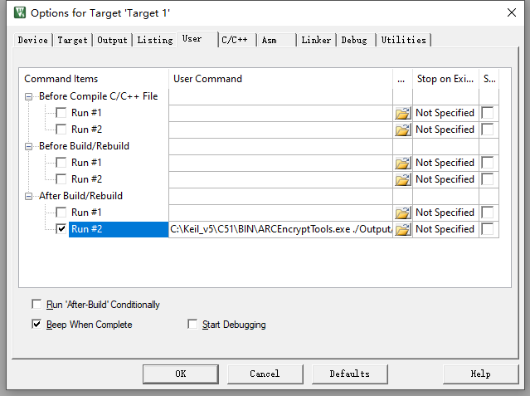

C:\Keil_v5\C51\BIN\ARCEncryptTools.exe

./Output/Radtel_RT900.hex QzBtDzKjYxGsWalkieTalkieBt8000OpenDate20241202

**3、Compliation result**

